7 Testing our TOP Network in Unity

1. Select ip_level_creation_top, Type Property, add Params

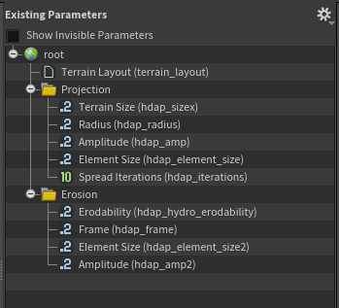

1. Copy Ip_level_creation_top.hda to Unity, select Terrain Layout file, HoudiniEngine > Create PDG Asset Asset Link;
2. Change HDA File Start with “$PDG_DIR”, Copy to Unity and Cook;